Please read the message below from the UMass president and chancellors, followed by a message from Interim Chancellor Katherine Newman.

To: The UMass Boston Community
From: President Martin T. Meehan
Re: COVID-19 Preparedness Update
The sudden arrival and spread of the coronavirus COVID-19 has had a profound impact on life here in Massachusetts and around the world. Given the uncertainties and risks of the moment, and in keeping with our steadfast commitment to the health and safety of the members of the UMass community, the five chancellors and I, in consultation with Chairman Manning, have decided to implement a remote teaching and learning plan to help protect our 75,000 students and 18,000 faculty and staff from the spread of the Coronavirus (COVID-19).
This morning I discussed our decision with Governor Baker, Senate President Spilka, and House Speaker DeLeo. All voiced their support for UMass as we confront this challenge.
Our highest priority is the health and safety of students, faculty, staff, and communities. The complex and fast-evolving challenges posed by this virus require decisive, proactive measures, and we have an obligation to do our part in mitigating the spread of the virus here in Massachusetts. After considering the guidance we have received from state and federal health officials as well as our own infectious disease experts, it is now clear that moving our students from face-to-face learning to a remote model must be part of our contribution to the mitigation effort.
This transition follows several weeks of discussion and consultation with our teams and Governor Baker’s declaration of a state of emergency. We are implementing these measures, not because there is presently any evidence that our campuses are unsafe, but in order to make them safer. Besides the one case at UMass Boston earlier this year (this student is recovering well and has been isolated since the discovery of his illness), no additional cases have been reported on our campuses. However, proactive steps are necessary to make our campus communities safer – for the students who return home and the faculty and staff who remain. These measures will reduce the density of our campus populations, which will enable social distancing.
It is important to be clear that we are implementing an alternative instruction modality and are not closing campuses or satellite sites. Specific details of the implementation on each campus will vary depending on each campus’ particular circumstances. Each campus is examining strategies to accommodate students with certain needs such as WiFi access, housing, etc.
Through April 3, classes will be taught remotely using web, video, and teleconferencing tools that are available to faculty, and are already being used in many classes throughout the UMass system. All five campuses have been preparing for this possibility over the last few weeks. We will reassess the situation as it progresses and notify students, staff and faculty by April 1 whether we need to prolong the distance learning modality beyond April 6. We are committed to ensuring to the best of our ability the progression of our students toward their degrees.
We regret the disruption that this will cause, but are confident that all parties will agree that the health and safety of those who live and work at the five campuses and dozens of UMass facilities across the state must come first.
Without question, this is a public-health moment the likes of which few of us have ever seen. Our hope is that the very significant steps being taken all around us will result in the virus being brought under control with as little impact as possible. Each campus will provide detailed instructions to their own students regarding implementation of the remote learning plan.
We are also adopting the recommendations that Governor Charlie Baker made Tuesday regarding executive branch employee activities. Though not a division of the executive branch, each campus and the system office will:
- Restrict work-related foreign and domestic travel of employees and discourage personal international travel.
- Hold conferences, seminars, and other discretionary gatherings virtually or cancel them.
- Continue internal business, including but not limited to mandated public hearings and board meetings.
- Discourage external work-related conferences, seminars and events. Alternatively, employees are encouraged to participate remotely.
- Discourage sick employees from coming to work.
- Encourage employees in high-risk groups (older workers, those with pre-existing conditions, etc.) to talk with supervisors about alternative work assignments.
Information about these actions will be disseminated to employees and the public today. Please visit Massachusetts.edu/COVID19 for updated information of system, campus, state and federal responses to this challenge.

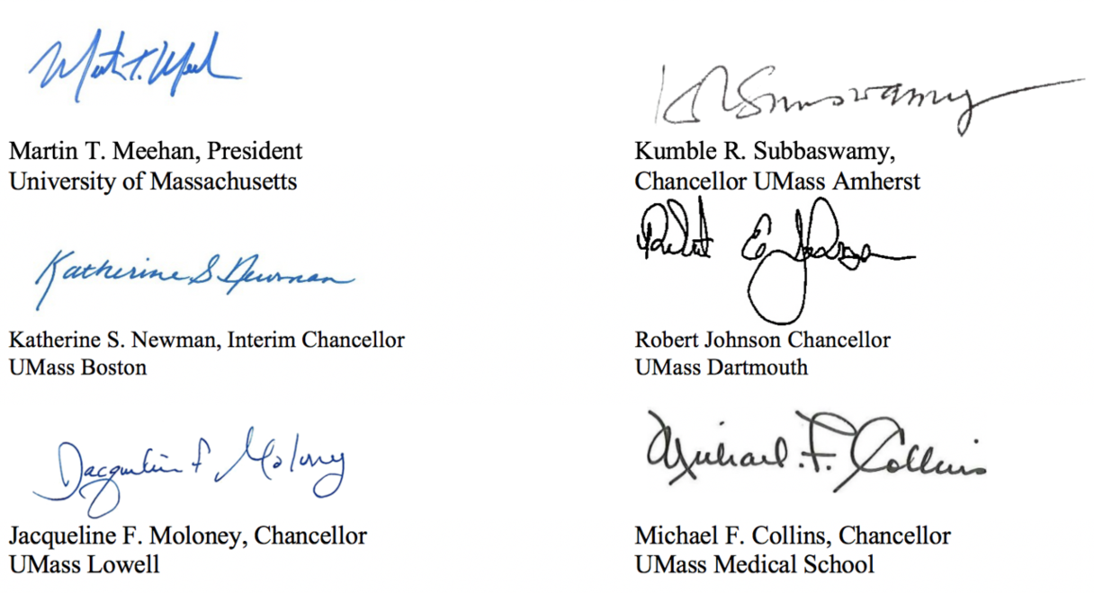

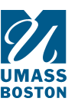  UNIVERSITY OF MASSACHUSETTS BOSTON |  | OFFICE OF THE CHANCELLOR  100 MORRISSEY BOULEVARD  BOSTON, MA 02125-3393  P:617.287.6800  F:617.265.7243  www.umb.edu

Dear colleagues, students, and staff,
Although the risk to our community of contracting the coronavirus (COVID-19) remains LOW, our campus continues to engage in extensive preparation to ensure the health and well-being of our students, faculty, and staff.
As UMass President Marty Meehan’s notes in his memo, we are now significantly stepping up our efforts to minimize the risk to our campus community. By moving coursework to remote modality during the period of Monday, March 23 to Friday, April 3, we will greatly reduce the density of people on campus.
In addition, we will be following the recommendations of Governor Charlie Baker, announced yesterday, immediately and for at least the next 30 days. These include:
- Cancelation of all upcoming university-related international travel
- Cancelation of all upcoming university-related domestic out-of-state travel
- Canceling events on campus involving more than 50 people and events that involve external parties coming to our campus
- Encouraging internal meetings to be held virtually or canceled if the virtual option is not feasible
- Providing remote work options to those employees who are at highest risk

For Students
All classes will continue as normal for the remainder of this week and then will resume in a remote format following the end of spring break (on March 23). As you plan for this change, please follow the guidelines below:
- Students should pack academic materials and personal belongings for spring break knowing that on-campus classes will not resume until April 6, at the earliest.
- Students in the residence halls need to depart from the residence hall by Saturday, March 21 at noon. Residents should pack their belongings understanding that they will not return to campus until noon on April 4, at the earliest.
- Resident students, especially international students, who feel that they have no other option may petition to remain in the residence halls. Details on how to do that are here.
Most important, be sure to check your email and university website regularly during the period of remote learning because this is our only way to keep you informed. We are working to provide as much information as possible on the UMass Boston coronavirus website and are opening a call center at 617.287.5400 to answer your questions.
Many of you may be disappointed with the change in your routine or the need to leave your home in the residence halls. We will make every effort to support your studies as we move forward. We are strongly discouraging students from coming to campus during spring break and the two week period of remote instruction. We will be working on a plan to maintain continuity of services that are essential to student well-being and academic success (health and mental health services, food, housing, internet access) and within the next 24 hours we will post a list of FAQ on the website.
For student athletes, the new guidance described above means that spring break trips are, unfortunately, canceled for all athletic teams. More details will follow soon regarding other upcoming athletic contests.

For Staff
Our goal is to ensure the safety of our community. By moving coursework to remote learning, the density of people on campus will be reduced significantly, which will lower risk to our staff who will remain on campus.
For now, university operations will continue as normal, and staff should continue to report to work unless you are sick. At the same time, staff should continue planning for the possibility of working remotely should that need arise at a later date.
Staff who feel that they are at higher risk due to age or other risk factors should consult their healthcare providers, and should speak to their supervisors about possibilities for remote work.
We are developing plans to maintain the continuity of campus research activities. UMass Boston will continue to support research-related facilities as usual, and employee access is not restricted at this time. A more detailed memo with protocols regarding research continuity is forthcoming.
We welcome everyone’s ideas about how to keep our community safe through increased social distancing and other measures, while we continue to support our teaching and research mission.

Other Campus-level Changes
In addition to the measures above, the campus has put in place a number of other changes, including:
- Shuttle bus service has reduced the density of riders. Buses will fill seats only, with no standing room permitted. In addition, each shuttle bus is being disinfected daily, with a focus on high touch areas.
- In the interest of reducing physical contact, we are working to reduce self-service options in our dining facilities. We have accelerated cleaning measures in all dining locations, with a focus on high touch areas.
- We are also working on a plan for consolidating dining services during spring break and until April
Our cleaning staff has been working diligently to thoroughly clean common areas on campus, with a focus on high touch areas.Particular attention is being paid to ensuring hand sanitizers remain stocked.
It is critical that we all continue to maintain healthy practices to prevent the spread of the coronavirus. As you well know by now, these include:
- Wash your hands often with soap and water (20 seconds of scrubbing) or use alcohol-based hand cleaners (cover all surfaces and rub until dry).
- Cough/sneeze into a tissue. Dispose of used tissues immediately into a trash can. If you don’t have a tissue, cough/sneeze into the crook of your elbow, not your hands.
- Avoid touching your eyes, nose, and mouth, which accelerates the spread of infections.
- Avoid close contact with others who are sick.
- If you are sick, avoid contact with others, including classes, parties, meetings, and events.
- Do not share glasses, eating utensils, water bottles, cigarettes/vapes/JUULs, lipstick/makeup, etc.
This is a rapidly evolving situation, and you can expect further guidance soon. We appreciate your patience and cooperation as we work to resolve the myriad of questions this new plan will raise. And we hope, despite the anxieties this situation produces, that you enjoy your spring break and return to your on line classes feeling refreshed. ;
Let me also thank the many members of the staff who have worked diligently and with a great sense of purpose to mobilize for this unusual moment in our history!
Sincerely,

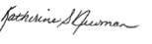
Interim Chancellor
Katherine Newman

© 2020 University of Massachusetts Boston
100 William T. Morrissey Blvd. Boston, MA 02125-3393

