Translation of item number 11860 by Angelica S Ramos 06/29/2021
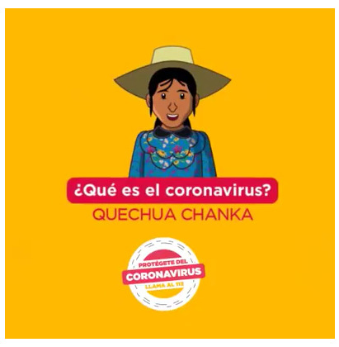
What is the coronavirus?
QUECHUA CHANKA –(translators note: These names refer to the Quechua people ethnic group living in the regions of Apurimac, Ayacucho and Lamas of Peru.
Protect yourself from the CORONAVIRUS DIAL 3

