Translation of item 10870 by Angelica S Ramos 07/06/2021
I learn at home
The classes continue
Monday April 13

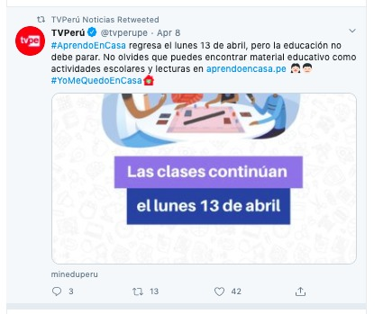
TVPeru
#ILearnAtHome will return Monday April 13, but the education should not stop. Don’t forget that you can find educational material like school activities and lectures on aprendoencasa.pe

