COVID-19 DAILY JOURNAL

(March 12, 2020 ~ April 12, 2020)

By Colin FitzGerald, High School History Teacher

Overview:

This journal represents a collection of thoughts, feelings, and perspectives of an American high school history teacher for one month during the 2020 coronavirus pandemic. It begins with the World Health Organization (WHO) officially declaring COVID-19 a pandemic and ends with a surreal Easter Sunday. For the most part, I try to capture the daily happenings of not only my classroom and school, but also the larger ripple effects that the pandemic is having in the community as a whole. As a history teacher, I realize that pandemics are mostly once-in-a-century events which ought to be documented for future historians to examine.

DAY 1 – 3/12/2020

Pandemic Declared: The COVID-19 pandemic became official yesterday, as the World Health Organization (WHO) has been tracking its origination and spread from Wuhan, China. Some school districts in the area have decided to close out of an “abundance of caution.” Yet my school district continued “business as usual” with Parent-Teacher Conferences (PTCs) still on the docket for tonight.

DAY 2 - 3/13/2020

Last Day of School: Friday the 13th was the last day of school for my district, as almost every surrounding district in the state had already closed. Many junior and senior students with cars in the parking lot actually staged a walk-out and left after second period. Most teachers left school that day not knowing if or when they would return to the building.

DAY 3 – 3/14/2020

Second Job: Fortunately, I have a second job as a liquor store clerk. It has served me well as a stress relief activity when compared to the daily happenings of school. I usually work some weeknights, but mostly on the weekends.

DAY 4 – 3/15/2020

Ides of March: We got word from the school district thru e-mail that schools would remain closed for two weeks. Teachers and staff started mobilizing for online education. But we are not terribly sure how accessible it will be for all students.

DAY 5 – 3/16/2020

Two-Week Quarantine: With school being off for two weeks, I started to pay more attention to the daily news briefings from various public officials. Much of what we know about COVID-19’s contagiousness and symptoms is that they last at least 14 days. So many states started implementing two-week quarantines for anybody who travelled outside the country.

DAY 6 – 3/17/2020

St. Patrick’s Day: Today I got in the Irish spirit by ordering corn-beef & cabbage from a local restaurant. A campaign slogan of “Take-out Tuesday” has started to go viral on the internet. It’s important to support local businesses in this trying time.

DAY 7 – 3/18/2020

Last Haircut: Today I decided to get a haircut out of fear that “non-essential” businesses might close in the not-so-distant future. Tipping 25-30% of the bill has become somewhat customary when visiting certain small businesses.

DAY 8 – 3/19/2020

Trapped Parent: Unfortunately, my mother has been in Florida for the past couple of months. As a Northerner who heads South during the winter months, she’s what people like to call a “snowbird.” I may have to navigate my way down there to help her move back home.

DAY 9 – 3/20/2020

Second Job Again: I started my shift at the liquor store again. Some aspects of the job have begun to change. We now mop the floor with bleach (Clorox) and water, as opposed to our typical Pine Sol concoction. My boss is also in the process of putting up a protective plexi-glass shield at the front counter.

DAY 10 – 3/21/2020

Buying a Plane Ticket: My mom requested help in moving her back North before states begin issuing quarantine orders. Perhaps domestic air travel might be shut down, just as it has been curtailed for many international flights.

DAY 11 – 3/22/2020

Plane Flight: Today I flew to Florida. It was an eerie experience. The one-way ticket cost me a measly $29 (with taxes) on JetBlue Airways. There were maybe 10 passengers on board. We all sat physically distanced between seats and rows. Only water was served on the flight. The flight attendants all wore gloves and masks, as did many of the passengers.

DAY 12 – 3/23/2020

Florida Day: I wanted the turnaround of my time in Florida to be quick. My mom was already mostly packed and ready to go. We had to close up the condo that she had been renting and load up the car for a 1,200 mile ride back North. I did not want to be away from my dog Lilly for more than a few days.

DAY 13 – 3/24/2020

Travel Day: My mom and I drove about 600 miles yesterday. We decided to spend the night in a North Carolina hotel, which was not far from the highway. We tried to keep up with the news updates, especially because certain states started issuing “stay-at-home” orders.

DAY 14 – 3/25/2020

Homecoming: I returned home late last night and woke to the news that my school district was going to start holding virtual staff meetings. The governor also extended the school closure until early May. At this point, my school district really started to ramp up the online education. What used to be optional “enrichment” activities were now becoming “mandatory” lessons for students to learn.

DAY 15 – 3/26/2020

Virtual Staff Meeting: My school held its first virtual staff meeting today. The principal sent out a Google Meet link, as the ever-popular Zoom Video application is notorious for being hacked. Unfortunately, some staff members forgot to turn off their microphones, so it was difficult to understand some people during the meeting.

DAY 16 – 3/27/2020

First Steps: The school district rolled out a “family contact” plan for staff members to communicate with students. The district needed to make sure every student had access to the internet, and more importantly, make sure that some students still had access to food.

DAY 17 – 3/28/2020

Back to Second Job: Work at the liquor store has been very busy. I witnessed a great deal of panic buying because people still think that we will be deemed “non-essential.” My boss and I are now taking extra-precautions by wearing a mask behind our plexi-glass shield.

DAY 18 – 3/29/2020

Sunday Fun-Day: Today my fiancée and I decided to go for a hike in the woods. We took our dog Lilly along for the trail walking. There was a large number of people out-and-about despite the new “social distancing” guidelines put in place by most states. However, the woods was still a good place to go to get away from the day-to-day lockdown misery.
DAY 19 – 3/30/2020

Social Distancing: Many states have issued “stay-at-home” orders which complement a series of social distancing guidelines. Whenever people have to venture out to the grocery store, pharmacy, gas station, or other “essential” businesses, they are encouraged to follow a set of rules that includes people standing 6-feet apart, wearing masks, and even gloves.

DAY 20 – 3/31/2020

More Virtual Meetings: The school district began to offer some guidelines for holding video chats online with students. Teachers now have to read about a 2-page disclaimer at the beginning of each Google Meeting. Some teachers feel these kinds of measures are discouraging virtual classrooms, but I can see why the school district wants to be careful here.

DAY 21 – 4/1/2020

April Fools: As the month changed from March to April, I slowly started to realize that school would not be returning any time soon (if at all for this school year). COVID-19 has really robbed the senior students of everything from spring sports to proms to possibly graduation. Many of my students are anxious to get back in the classroom, because virtual learning is not an adequate alternative.

DAY 22 – 4/2/2020

Grading & Attendance: One of my primary concerns with virtual learning is how to account for student engagement. Some students, no matter how much I post in Google Classroom, simply will not complete the work. We have been advised from the district to keep track of “student engagement,” but not to grade any student work.

DAY 23 – 4/3/2020

Pass or Fail: If school does not return for the remainder of the academic year, then we will be required to assess students on a simple pass/fail basis. There’s no need to continue the 0-to-100 scale, as the “quality” aspect of student work is not considered. It’s all about effort now.

DAY 24 – 4/4/2020

Back to the Store: Sales at the liquor store have begun to flatten. The panic buying has definitely disappeared, as people realized that we did not have to close. Some random customers do arrive at the store asking for items like milk, toilet paper, and bread.

DAY 25 – 4/5/2020

Sunday Anxiety: Teachers normally have some degree of “Sunday anxiety” during the school year while preparing for an upcoming week. But with virtual learning, the anxiousness seems to creep into our collective consciousness in different ways. How do I reach these kids?
DAY 26 – 4/6/2020

Online Learning Continues: Students are starting to give me feedback on the various assignments that I have given. My honors-level kids want more challenging materials. Differentiating my assignments is becoming increasingly difficult. Unsure about how to proceed.

DAY 27 – 4/7/2020

Absurdity & Surrealism: The monotony of my daily routine is becoming hard to accept as reality. Everyday appears to be exactly the same. I try to incorporate an exercise regimen into my daily schedule, but finding the motivation is tough somedays. Emails & news seem to consume much of my attention and focus.

DAY 28 – 4/8/2020

Awkward Family Visit: Today my mother and I actually ventured a few towns over to see my cousin’s new house. Of course, we could only drive by and wave from a distance, but seeing other family members provided a positive boost to my psyche. There will be better days.

DAY 29 – 4/9/2020

The Surge: For weeks, the news updates from public officials have centered on two main phrases: “social distancing” and “flatten the curve.” Both of these phrases are geared toward keeping the healthcare system from becoming overwhelmed by COVID-19 patients. In my region, the surge or apex in coronavirus cases is supposed to start around today and continue for the next 7-to-10 days.

DAY 30 – 4/10/2020

Good Friday: With the liturgical season of Lent coming to an end for Christians, there appears to be an unending list of items upon which to reflect. I hope that this pandemic experience pushes people to take time and think hard on how to emerge as a better person. There are lessons abound for all of us to learn here. Every sector of society needs to adapt and adjust.

DAY 31 – 4/11/2020

Second Job at Store: We still have our regular crop of customers at the liquor store. Unfortunately, I have witnessed a significant rise in credit card fraud. Fraud customers will come into the store seeking expensive champagne, cognac, or tequila. They purposely use broken “chip” cards to trick the payment processer into using the old “swipe” method.

DAY 32 – 4/12/2020

Easter Sunday: Eating ham today was surreal. Morning mimosas were fun, but not getting together with the normal lot of family made today difficult. In the end, I must keep the faith because this too shall pass.
Some journal characters…
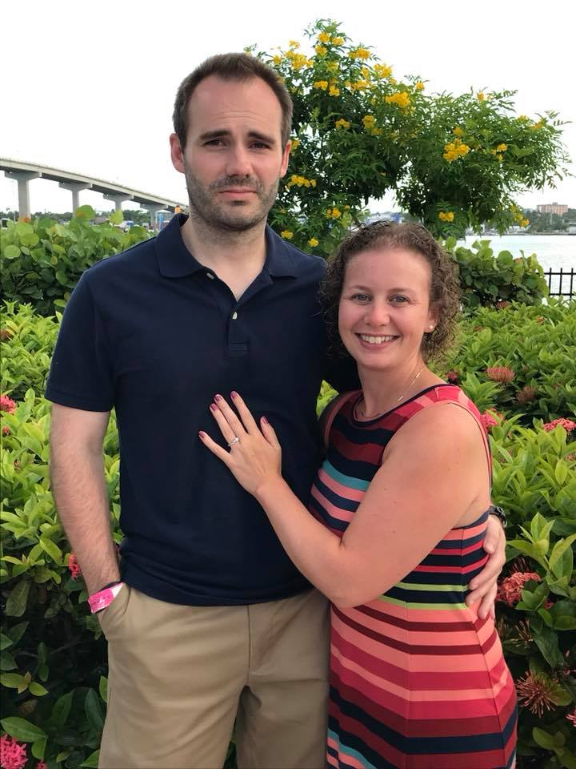
Author and fiancée

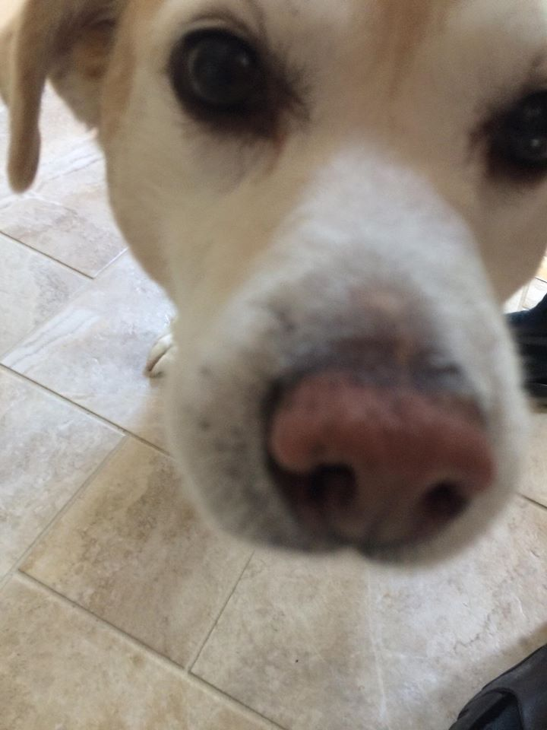
Author’s dog, Lilly

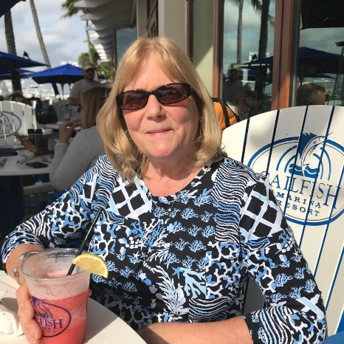
Author’s mother

