Translation of item number 16798 by Angelica S Ramos 06/29/2021
*ALL IMAGES HAVE THE SAME HEADER*-
Histories
A quarantine diary, by Andres Edery
Again Andres – Look at the graphics Andres Edery has published in the magazine since 2018. Politics, National, International, Lima, Sports, our country: all summarized in his drawings
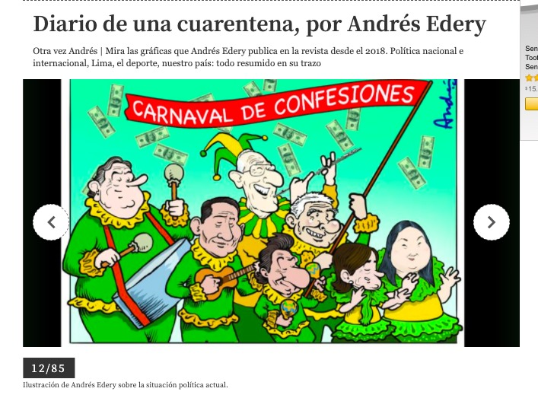
CARNIVAL OF CONFESSIONS
12/85
Illustration by Andres Edery about the current political situation
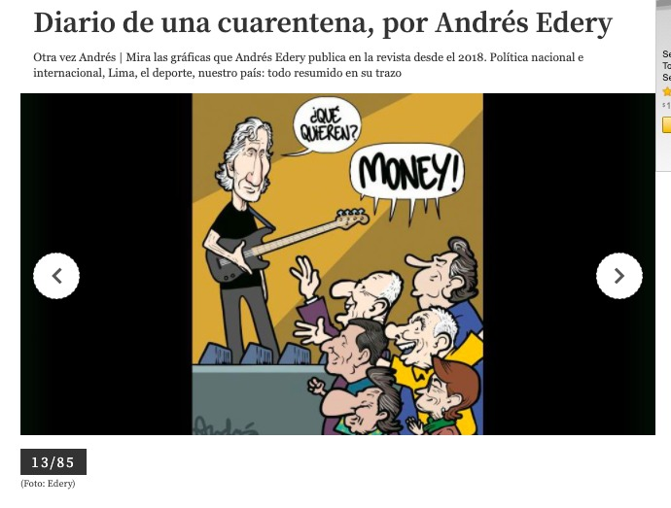
“What do you want?”
“Money”
13/85
(picture:Edery)
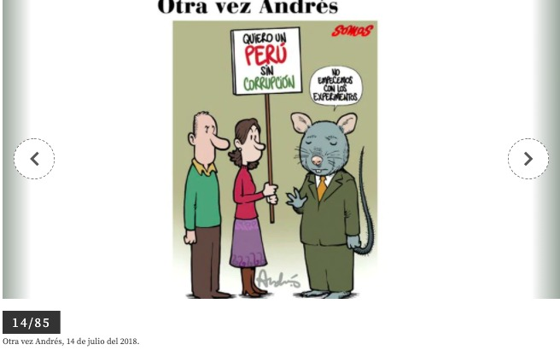

“I want a corruption-free Peru”
“Lets not starts with experiments”
14/85
Again Andres, July 14, 2018.
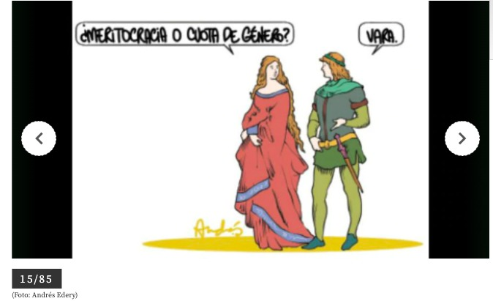
“Meritocracy or gender quota?”
“Vara” (translators note : Vara is a length of measurement, a yard)
15/85
(picture: Andres Edery)
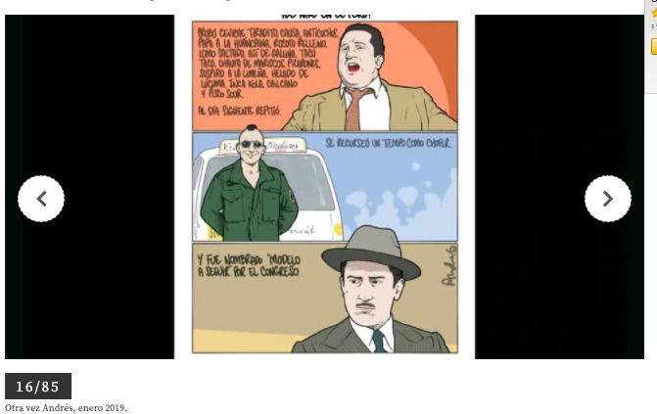
“I hate ceviche, tiradito, anticuchos, papa a la huancaina, rocoto relleno, lomo saltado, aji de gallina, taco, chaufa de mariscos, picarones, suspiro a la limena, helado de lucuma, inca kola, chilcano de pisco sour. The next day I’ll repeat”
“He spent some time as a driver.”
“And was named “model to follow” by congress”
16/85
Again Andres, January 2019.

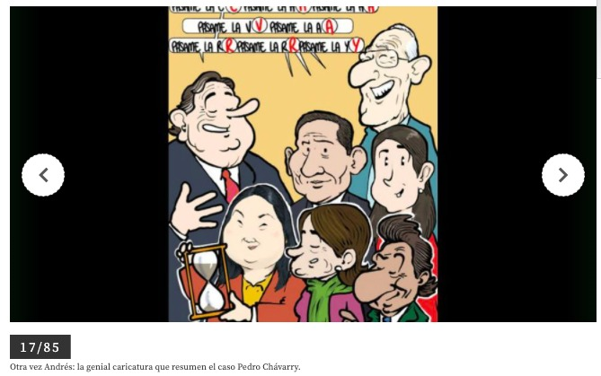
“Give me a c. C. Give me an h. H. Give me an a. A. Give me a v. V. give me an a. A. Give me an r. R. Give me an r. R. and a y. Y”
17/85
Again Andres: The great cartoon that summarizes the case of Pedro Chavarry.
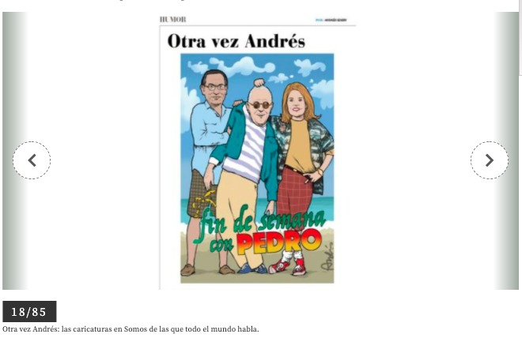
“Weekend with Pedro”
18/85
Again Andres: the cartoon in Somos that the whole world talks about.
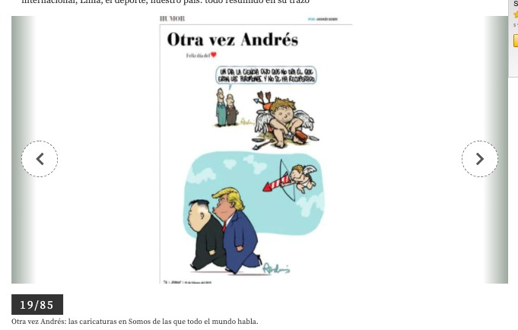
“One day science said it wasn’t him. That is was the pheromones. And he hasn’t recovered.”
19/85
Again Andres: the cartoons in Somos that the whole world is talking about.
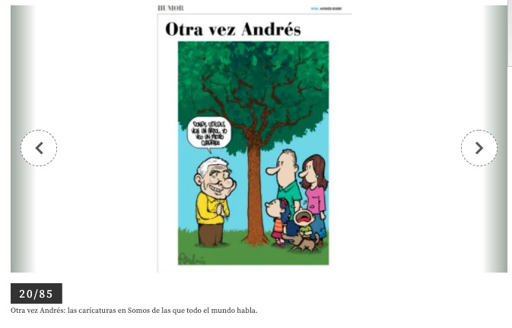
“Where you see a tree, I see a square meter.”
20/85

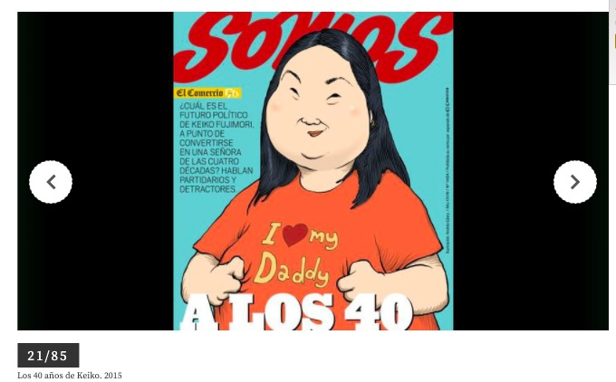
Somos
Trade
What is Keiko Fujimori’s political future, is she about to become a woman of four decades? Supporters and opposers talk.
AT FOURTY
21/85
The forty years of keiko
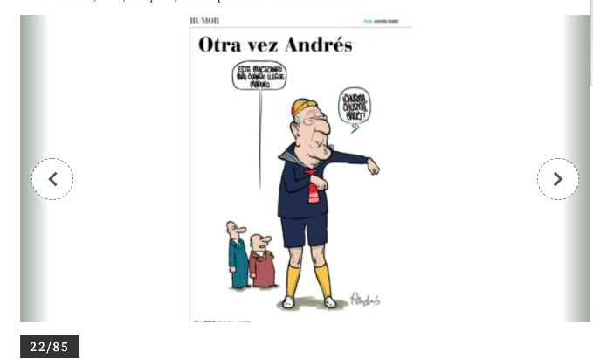
“He’s practicing for when Maduro gets here”
“chusma, chusma, PRRRT” (translator note: chusma means “low life”)
22/85
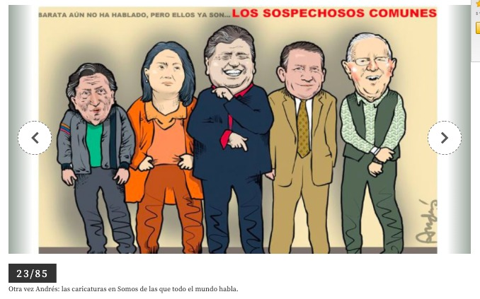
Barata hasn’t spoken yet, but they are the COMMON SUSPECTS
23/85
Again Andres: The cartoons in Somos that the world is talking about.
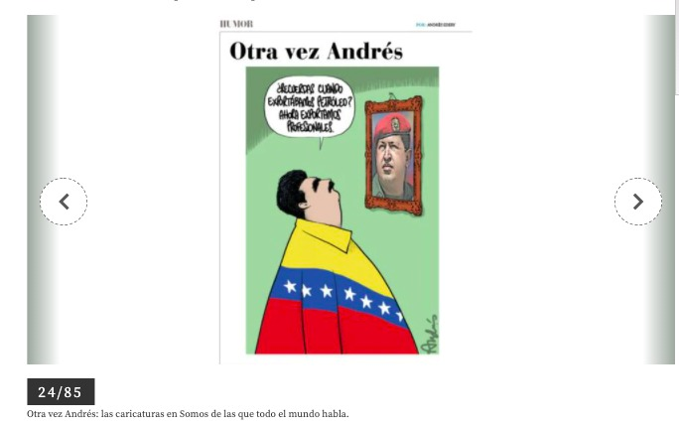
“Remember when we used to export petrol? Now we export professionals.”
24/85

