COVID-19 Visions Project
Johnny Martinez
Sociology
20200422

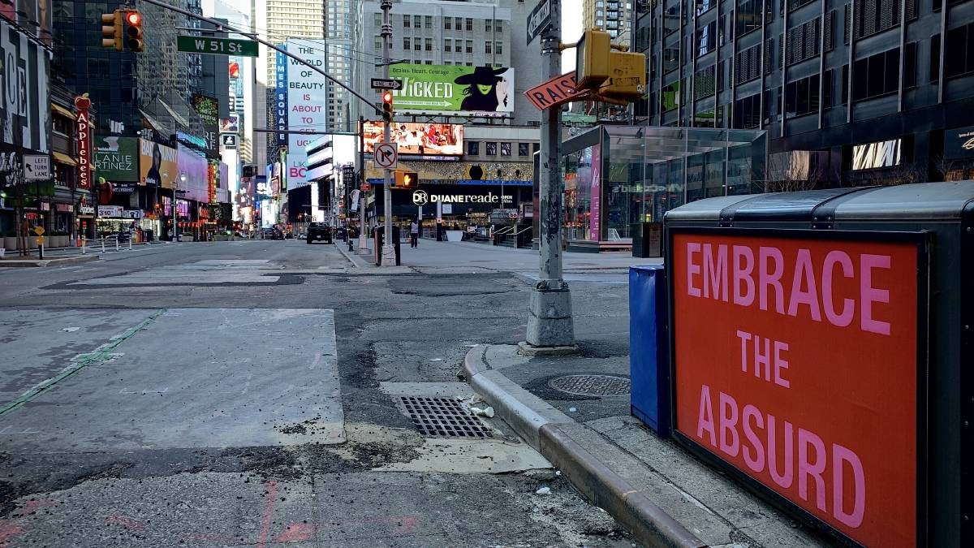
Figure 1. A New York state of mind: Simone De Peak captured the city's empty streets as COVID-19 hit the Big Apple (https://www.newcastleherald.com.au/story/6687545/a-new-york-state-of-mind-simone-de-peak-captured-the-citys-empty-streets-as-covid-19-hit-the-big-apple/#slide=1)

Micro Context
My generation has continued to have an intense obsession and fear of a zombie apocalypse despite having lived through 911 and the Great Recession. It’s been the most common topic in film, video games, and other forms of media art for the past thirty years. It’s apparent we are not ready nor could survive such a pandemic at this point in time. Since the beginning of January, rumors of a cold virus with a stronger pathology and transmission rate began to circulate. China was hit. Italy was devastated. Before long, the virus had reached North America: officially making it a world-wide pandemic. State officials quickly responded with closures and regulations to reduce transmission rates and keep medical facilities from being overwhelmed. These regulations most emphasize social distancing and isolation resulting in an economic crisis.
I chose the photo above because it perfectly depicts the obvious outcomes from newly-imposed federal and state regulations. This is a photo of New York City during week three in quarantine. The city that never sleeps is so baron one can see filth in the gutters and sidewalks which are usually camouflaged by millions of feet and baggage. You can see that the once- electric city, now, has its lights off (probably to conserve energy costs) and is reflected by a gloomy afternoon sky. One of the largest economic cities has completely shut down. This is what a global pandemic looks like. The subtly written messages in the photo intrigue me, as well, and may not be as -obvious-as the others listed above. Large gatherings including performance art shows have been brought to a rapid hault indefinitely. Yet, in the far distance, we can see an advertisement for the production “Wicked” and an “embrace the absurd” billboard above a subway entrance.
Embracing the wicked and absurd is probably the most challenging aspect of the COVID-19 pandemic in our community. No one would have thought places such as New York City or San Francisco could shut down in our lifetime except for a zombie apocalypse. Individuals across the world, especially in these cities, are feeling the personal negative effects from having their daily schedules disrupted and, for many, negative financial impacts. Even worse, humans are social creatures and we feel cut-off from our typical support systems by seizing these human interactions. We are very vulnerable right now.
Macro Context and Analysis
Geertz suggests that a thickly described narrative is pertinent to the ethnography of a population because all sociological meanings have multiple layers and they may not be very obvious. I like this photo because, like all meanings, it has many layers. On one hand, we have the depiction of an empty city and streets because of an enforced order for social distancing and isolation. On the other hand, we have messages suggesting this order isn’t widely accepted or predicted, first, by a written message in the foreground “embrace the absurd” and a headline in the background that reads “Wicked”. This suggests (from an institutional ethnographic viewpoint) the streets are emptied for conflicting reasons and may reflect how the community as a whole feels about the situation. ‘Absurd’ is a bizarre word choice as it usually has a taboo or negative connotation. Choosing to put the ‘accept’ and ‘absurd’ together inflicts a degree of skepticism to the reader, in this case, pertaining to the stay-at-home order.
One aspect of the photo I feel is greatly overlooked is the lack of people subsisting on the streets. As depicted in “Sidewalks”, NYC is full of people whose livelihood comes from side gigs such as vendors and panhandlers (especially immigrants) whose basic human needs are ignored. It’s hard not to assign an interpretive meaning to this population when considering their resourcefulness in these modes of survival. According to this photo, it appears as though even the subsisting community is negatively affected by the COVID-19 pandemic. It’s unclear if this is due to fears of catching the virus themselves or due to economic strains from the general population for whom they depend on. Perhaps it’s a true representation of Geertz’s thick ethnographic theory because it is all of the above: layered. However, it is apparent that every demographic in the city has been affected including the modern-day Unforgettables.
Self- Reflection
I am a combat veteran. I’ve traveled the world and the USA using this trade as a primary source of income and way of helping others for the past 12 years. Additionally, I’ve known this career and status to be the most secure even in times of economic crisis. I never expected this to change. COVID-19 has been one of the scariest events to witness. My city is on lockdown. The streets are baron and mimic paper towns from the Manhattan Project. The most frightening thought as a single parent is preparing myself and my loved ones for the events to follow. It’s hard not to feel lonely, stressed or depressed right now with everything feeling so abnormal.
I feel a deep responsibility to take care of my daughter and parents during this time of crisis. Although I am receiving grants to go to school, I fear that funding will be pulled due to strains on the economy. Returning to work doesn’t seem feasible for anyone anytime soon nor does federal funding seem like a sustainable source of income. I fear my current resources won’t be enough if current events go on for much longer.
I agree with the federal and state officials' decision to impose social distancing bans. Even though my health is OK, I believe the most vulnerable population in all of this is the elderly and they need to be protected. Because I have parents in this demographic, I feel particularly worried for their safety. At the same time. I believe younger generations are taking this as an excuse to remove themselves from personal responsibilities to these older generations. It angers me that this pandemic has even been meme’d with captions such as “The Boomer Doomer” for entertainment purposes. I’ve noticed some stores open early to safely attend to these elderly populations and persons with compromised immune systems, but, I still fear it’s not enough with regards to safety precautions. My community should unite to bring more resources to this demographic such as free delivery services and daily phone-call “check-ins. This would, also, be an effective way for all people, not just the elderly, to feel more connected to one another during this period of isolation. I think helping others and having a sense of worth is the best way to overcome loneliness, stress and depression.

