THE LOCAL – March 19, 2020
https://www.thelocal.it/20200308/should-you-be-concerned-about-the-coronavirus-in-italy

PAYWALL FREE
UPDATE: Here's the latest information about the coronavirus crisis in Italy
The Local
news@thelocal.it
@thelocalitaly
8 March 2020
10:44 CET+01:00
Updated
19 March 2020
19:11 CET+01:00
healthcoronavirus
Share this article
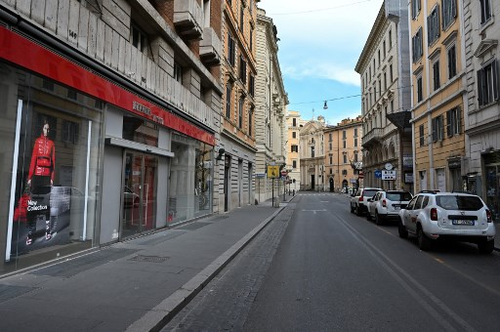

Photo: AFP
Italy has now reported more coronavirus deaths than China, as the number of confirmed cases of coronavirus passed 41,000. Here's what you need to know about the current situation and the risks. (Paywall Free)
What's the situation in Italy?

Italian official announcd the country had recorded a total of 3,405 deaths on Thursday night, compared to China's 3,245.
The number of fatalities announced on Thursday was lower than the record high of 475 fatalities on Wednesday -- the highest official one-day figure in the world.
The number of confirmed cases in Italy also jumped to 41,035 on Thursday, up from 35,713 in 24 hours.
This figure ncludes the deceased as well as 4,440 patients who are now said to have recovered from the illness caused by the virus.
China reported no new infections for the first time on Thursday.
Italian hospitals now have almost 2,500 patients in intensive care.

READ ALSO: What do we know about those who have died in Italy?
More than 41,000 people have now been diagnosed with the virus since the outbreak began in Italy in late February.
This figure includes those who have died as well as the 2,941 patients who have now recovered - 192 more than on Monday.
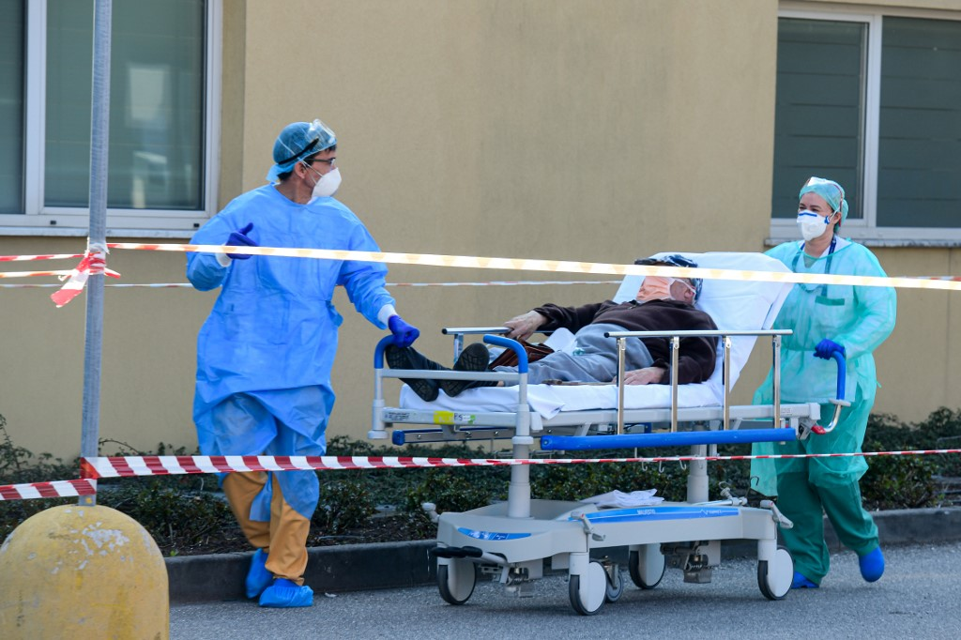
Photo: AFP
The focus of the outbreak is still the northern region of Lombardy, which has seen around two thirds of the total deaths, and almost 20,000 of all confirmed cases.
Almost all regions in Italy have now reported at least one death, although up until now the south has been less affected than the north.
Nevertheless hospitals in the poorer southern regions are on red alert as they prepare for an outbreak.
How is Italy responding to the crisis?
The whole of Italy has been placed under quarantine measures and ordinary life has been hugely affected across the country.
On Thursday March 19th the italian government announced the current lockdown would be extended beyond the initial deadline of April 3rd but did not give a new date, saying it would be announced "in the next few days".
Many readers have been asking us questions about the rules of quarantine. We have tried to answer as many questions as we can in this article (paywall free).
Italy has already shut all stores except for pharmacies and food shops and asked businesses to let employees work from home or take leave.
People are asked not to go out unless they need to – for example, to buy groceries or go to work. All travel is banned without a "serious" reason that cannot be postponed. People are also able to travel to return home.
Anyone found flouting the new rules could face a fine or even up to three months in prison, the government said.

READ ALSO: Your questions answered about the coronavirus lockdown in Italy
The government is also reportedly considering even tighter restrictions after many officials complained that too many people were out on the streets and in parks.
It will take days or weeks before Italy sees the numbers of infected and deceased stop rising due to the quarantine measures, experts said on Wednesday.
A poll on Thursday found 96 percent of all Italians support the quarantine measures, viewing the closure of most business and all schools and public institutions "positively" or "very positively", and just four percent said they were opposed.
While some public transport is still running, most intercity and long-distance trains have been suspended.
Travel to and from Italy has been affected. On Thursday March 12th it was announced that Rome would close Ciampino airport and one terminal Fiumicino airport due to a lack of demand and many of the country's long-distance Frecciarossa trains have been suspended as of Friday 13th.
Big businesses such as factories remain open as long as they adopt "appropriate security measures to prevent contagion."
Ceremonies such as marriages and funerals are banned (though burials go ahead behidn closed doors) and many churches have now closed their doors. Bars, cafes and restaurants have also closed, though many are offering home delivery to customers, as everyone is advised to stay at home.

READ ALSO: The form you need to go outside under Italy's new coronavirus rules

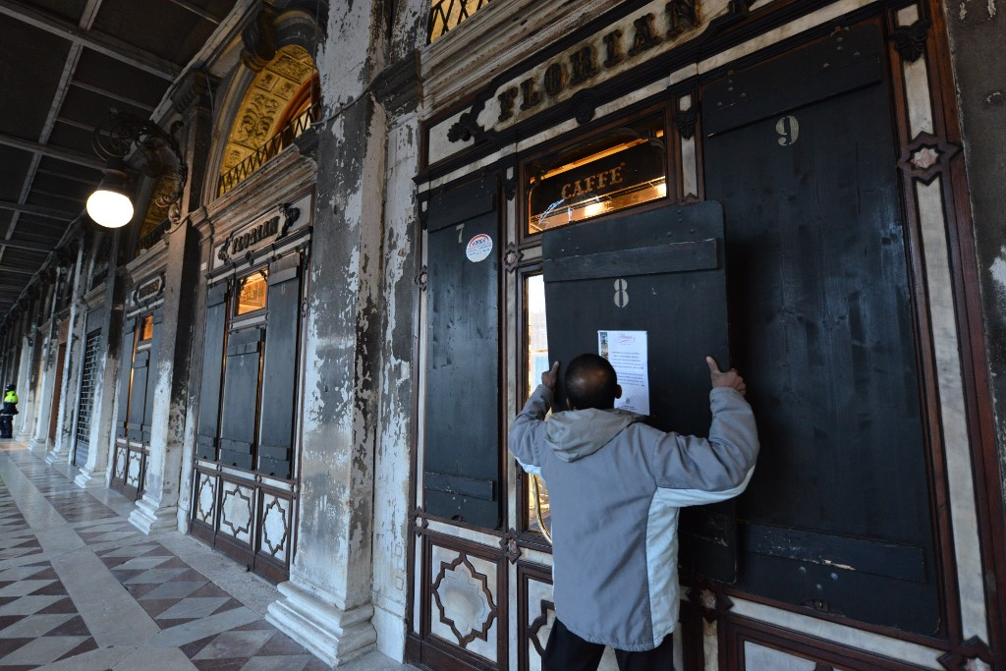
Photo: Piero Cruciatti/AFP

What about travel to Italy?

Travel to Italy is becoming almost impossible and now not advised by most governments. On Thursday Italian airport authorities announced Rome would close Ciampino airport and one terminal at Fiumicino.

Numerous airlines have cancelled flights, while countries like Spain have suspended all flights from the country.

The US President Donald Trump announced on March 11th a travel ban for the 26 EU nations in the Schengen zone. US nationals and US permanent residents will be allowed to return home after the ban comes into force on Friday March 13th. However, that will depend on whether they can find flights.

READ ALSO: What Trump's travel ban means for you

The United States has issued a Level 3 travel warning for the whole of Italy, advising against all non-essential travel to the country due to "widespread community transmission" of Coronavirus, and it has issued a level 4 "Do not travel" warning" for the worst-affected regions of Lombardy and Veneto.

The British government's Foreign and Commonwealth Office is now advising against all but essential travel to Italy.

"The FCO now advises against all but essential travel to Italy, due to an ongoing outbreak of coronavirus (COVID-19) and in line with various controls and restrictions imposed by the Italian authorities on 9 March," it states.

CLICK HERE for all the latest guidance regarding travel to Italy.

The British government is now asking anyone who has returned to the UK from anywhere in Italy to "stay indoors and avoid contact with other people", even if they do not have symptoms.

Austria and Slovenia have imposed border restrictions with Italy, as has Switzerland.

Many other countries are also now advising citizens to postpone travel to northern Italy, while some say passengers returning from affected areas could face temperature checks or quarantine upon arrival.
So while foreign citizens are allowed to leave Italy, and may have to show their airline tickets at police checks, they may find it more difficult due to a lack of flights.
What is coronavirus?
It's a respiratory illness which belongs to the same family as the common cold.
The outbreak in the Chinese city of Wuhan – which is an international transport hub – began at a fish market in late December.
According to the WHO, more than 80 percent of patients infected with the virus have mild symptoms and recover, while 14 percent develop severe diseases such as pneumonia.

The elderly and people with conditions that weaken their immune system are most likely to develop severe symptoms.

What are the symptoms?
The initial symptoms are not dissimilar to the common flu, as the virus belongs to the same family.
The symptoms include a cough, headache, fatigue, fever, aching and difficulty breathing.
COVID-19 is primarily spread through airborne contact or contact with contaminated objects.
Its incubation period is two to 14 days, with an average of seven days.
READ ALSO: The everyday precautions to take against coronavirus if you're in Italy
How can I protect myself?
You should follow the government's guidance as well as taking the same precautions in Italy that you would anywhere else:
Wash hands thoroughly and often with soap and water, especially after coughing and sneezing or before eating.
Avoid touching your eyes, nose or mouth, especially with unwashed hands.
Cover your nose and mouth when coughing or sneezing.
Avoid close contact with people who have symptoms of respiratory illness.
Wear a mask if you suspect you are ill, or if you are assisting someone else who is ill.
Clean off surfaces with alcohol- or chlorine-based disinfectants.
Do not take any antibiotics or antiviral medication unless it's been prescribed to you by a doctor.
You don't need to worry about handling anything made or shipped from China, nor about catching coronavirus from (or giving it to) a pet.
You can find the latest information about the coronavirus in Italy from the Italian Health Ministry, your country's embassy, or the WHO.
What should I do if I think I have COVID-19?
If you think you have the virus, do not go to hospital or your doctor's surgery.
Health authorities are worried about potentially infected people turning up at hospitals and passing on the virus.
A special Italian health ministry phone line has been launched with more information on the virus and how to avoid getting it. Callers to the 1500 number can get more information in Italian, English and Chinese.
In an emergency situation, you should always call the emergency number 112.
According to the WHO, around 80 percent of people who contract the new coronavirus recover without needing special treatment.

Around one out of every six people who gets COVID-19 becomes seriously ill and develops difficulty breathing.

Some 3.4 percent of cases are fatal, according to the latest WHO figures. Older people and those with underlying medical problems like high blood pressure, heart problems or diabetes, are more likely to develop serious illness.

Italian vocabulary
a fever – una febbre
a headache – un mal di testa
a cough – una tosse
a cold – un raffreddore
the flu – l'influenza
the coronavirus – il coronavirus

