Translation of item 17470 by Angelica S Ramos 07/07/2021
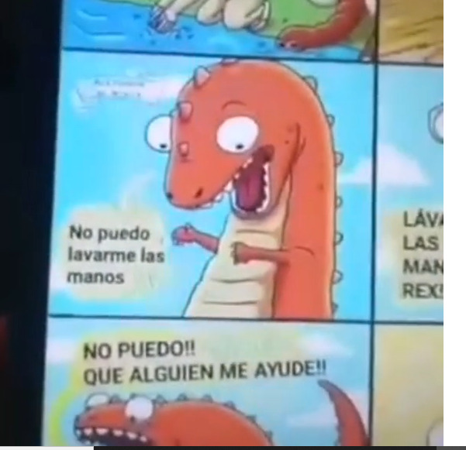
“I cant wash my hands”
“I cant! Someone help me!!”

