Translation of item 22554 by Angelica S Ramos 07/07/2021
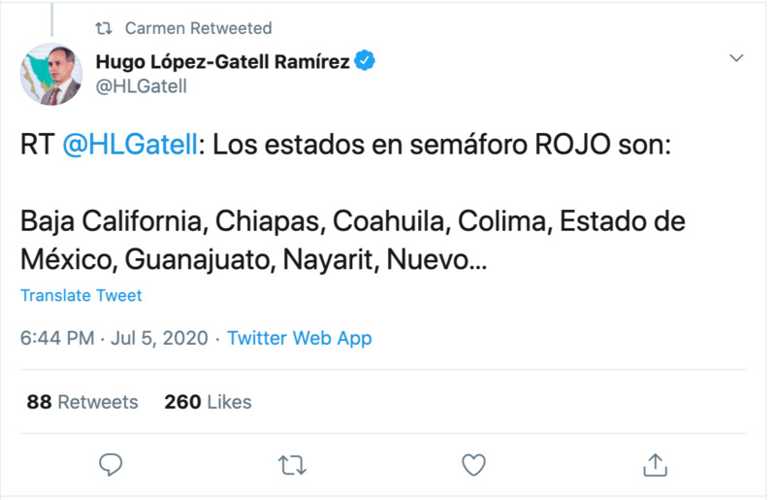
RT @HLGatell: The states in the RED sphere are:
Baja California, Chiapas, Coahuila, Colima, Estado de Mexico, Guanajuato, Nayarit, Nuevo…

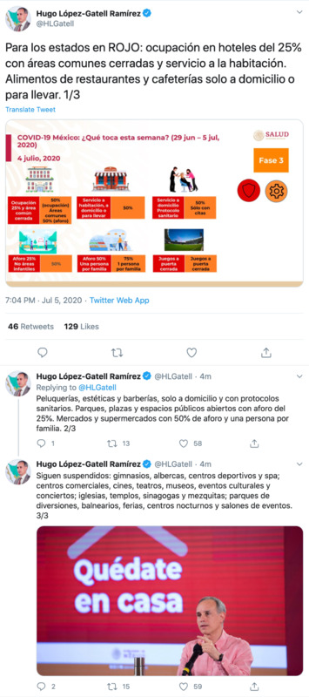
Hugo Lopez-Gatell Ramirez
For states in RED: hotel occupation is at 25% with closed common areas and room service. Food from restaurants and cafeterias only for take out or home. 1/2

Covid-19 Mexico: What’s up this week? (Jun 29 – Jul 5, 2020)
July 4, 2020 Faze 3

Occupation 25% and closed common area - 50% (occupation) common areas 50% (capacity)
Room service, home service or take-away service - 50%
Home service Health protocol - 50% Appointment only
25% No children's areas - 50%
Capacity 50% One person per family - 75% 1 person per family
Closed door games - Closed door games

Hugo Lopez-Gatell Ramirez
Hairdressers, aesthetics and barber shops, only house calls with sanitary protocols. Parks, squares and public spaces open with a capacity of 25%. Markets and supermarkets with 50% capacity and one person per family. 2/3

Hugo Lopez-Gatell Ramirez
still suspended: gyms, pools, sports centers and spas; shopping centers, cinemas, theaters, museums, cultural events and concerts; churches, temples, synagogues and mosques; amusement parks, spas, fairs, night clubs and event rooms. 3/3

“Stay at home”

