Translation to item 12412 by Angelica S Ramos on 06/30/2021
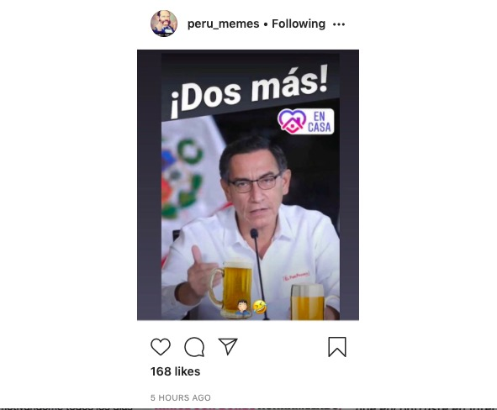
Two more!

