Translation of item number 16796 by Angelica S Ramos 06/29/2021

A quarantine diary, by Andres Edery
Again Andres – Look at the graphics Andres Edery has published in the magazine since 2018. Politics, National, International, Lima, Sports, our country: all summarized in his drawings
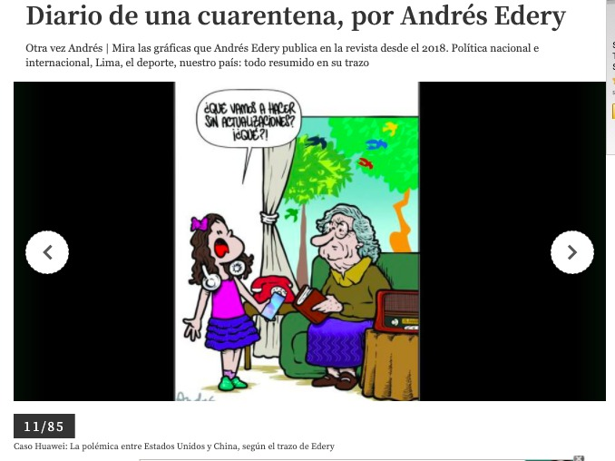
“What are we going to do without updates? What?”
11/85
The Huawei Case: The controversy between The United States and China, according to Edery

