Translation of item 10861 by Angelica S Ramos 07/05/2021
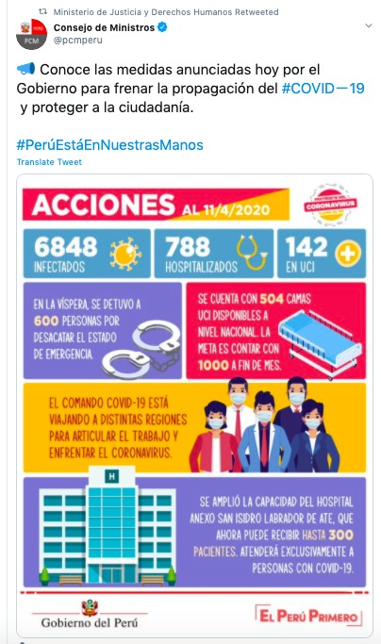
“Know the measures announced today by the government to stop the spread of Covid 19 and protect fellow citizens
Actions 04/11/2020
6848 infected
788 hospitalized
142 in ICU
In the vispera 600 people were arrested for violating the state of emergency
There are 504 bed available in the ICU at the national level. The goal is to have 1000 by the end of the month.
The command in charge of COVID-19 is traveling to distant regions to get to work and deal with the coronavirus.
The capacity of the hospital annex San Isidro of Ate was expanded and can now receive up to 300 patients. It will exclusively serve people with COVID-19.
Peruvian Government
Peru First”

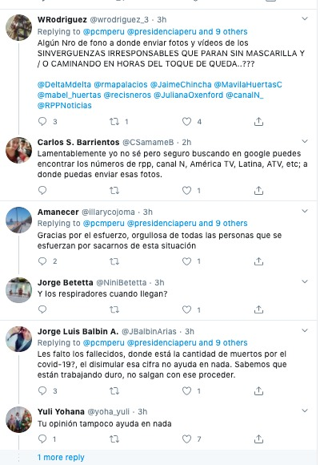
WRodriguez
Is there a phone number to send pictures and videos of those IRRESPONSIBLE SHAMELESS PEOPLE WHO WALK AROUND WITHOUT MASKS AND WALK AROUND AFTER CURFEW???

Carlos S. Barrientos
Unfortunately I don’t know but surely you can find the numbers of the rpp, canal N, America TV, Latina, ATV, etc on google to send them pictures.

Amanecer
Thanks for the effort, I’m so proud of all those people that are working to take us out of this situation

Jorge Betetta
When are the ventilators coming?

Jorge Luis Balbin A.
Your guys forgot those who have died, where is the number for those who have died from covid-19? It doesn’t help anything to diminish that number. We know youre working hard, don’t come with that behavior.

Yuli Yohana
Your opinion also doesn’t help anything

International Orchestra Son D’Sabor
At last its here
“I got the government aid package for self-employed workers and businessmen”

Denisse Magdalena
I am grateful for your great effort, but I think they should declare a 24 hour curfew in the most disobedient districts and the municipal districts should organize to sell or donate food.

Kevin Tamayo
and about the PL of the AFP, when will that be

Te (heart) 3000 Peru
hopefully the covid command will come soon to La Libertad and put at helm people who do know about strategies and public health to head this crisis and the irresponsibility of my countrymen

Anali Fuentes
people who do not comply with the presidents measures, who go out and do communal work should pay a fine, I do not understand why they are so foolish and overbearing, in this time of crisis they have demonstrated a high level of ignorance they don’t respect anyone, they beat authority.
ANGEL MORALES
Respect the law, national emergencies are managed by INDECI, and of course by Minsa (as a sector) but clear guidelines must be established to optimize resources in local “gob” and “reg” Instead of creating more workspaces like the command…

VINCENT The Coer – Indeci does not work – imagine they Coer Lambayeque has hundreds of family modules in the open elements hurting and when it rains never act. A big error

Jorge Holguin
They can utilize the hospital of Los Olivos

Carlos Eduardo
181 is in the MINSA page, google exists to search

Gissellavalderrama
We have been waiting since Wednesday for them to test my brother. That means if they don’t come to the call that means that the figures are invented, we call the numbers and they are all off, where is the support they talk about, I have a 4 year old daughter and I am scared

Paseos En Yate La Sirenita-Ancon
The detected carriers of the coronavirus need to be fed and isolated, even in schools so they don’t continue to spread

Josue
day to day use of respirators for COVID-19! Peru

Veronica
Is that the advance of today? IF YOU WORK YOU DON’T CARE! EFFICIENT ACTION NOWWW!!!!!

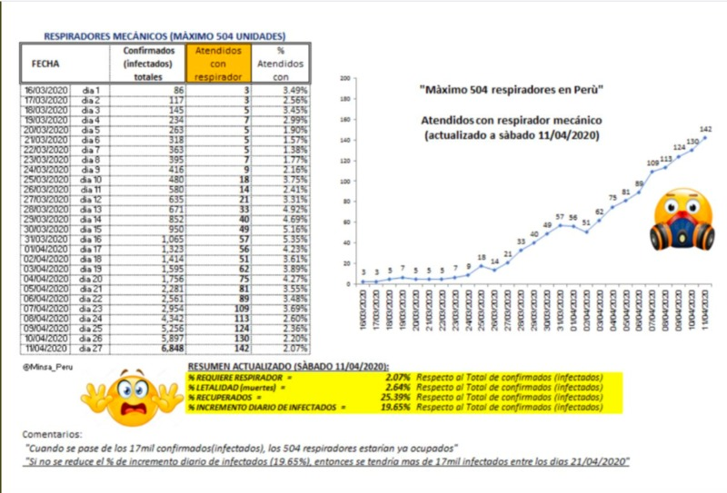

MECHANICAL RESPIRATORS (MAXIMUM OF 504 UNITS)
DATE – TOTAL CONFIRMED (INFECTED) – THOSE ON RESPIRATOR - % OF PATIENTS ON RESPIRATOR

“MAXIMUM OF 504 RESPIRATORS IN PERU”
THOSE ON A MECHANICAL RESPIRATOR (UPDATED SATURDAY 04/11/2020)

COMMENTS: “WHEN IT SURPASSES 17 THOUSAND (INFECTED), THE 504 RESPIRATORS WILL ALL BE IN USE” “IF THE % OF THOSE INFECTED IS NOT REDUCED TO 19.65% THEN THERE WILL BE MORE THAN 17 THOUSAND INFECTED BY 04/21/2020

