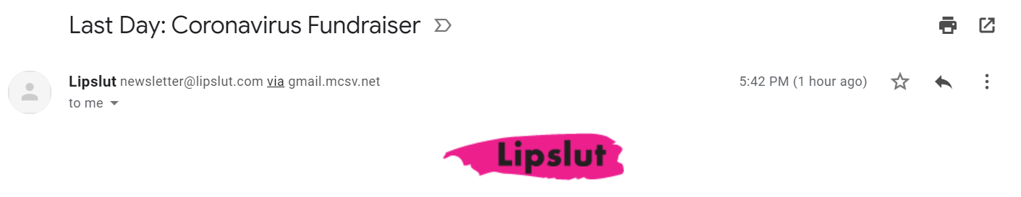
Friday, March 20
Just wanted to send out a reminder about our Coronavirus Fundraiser. We’ve pledged to donate 100% of earnings sitewide to help those impacted by the virus.
With millions of children home from school and unemployment skyrocketing the need is real.
Today is our last day of the fundraiser in case you wanted to participate! Even if you aren’t in a place to make a purchase, sharing one of the articles below can help make an impact:
Lipslut Coronavirus Fundraiser coverage:
- Refinery29
- PopSugar
- InStyle
- The Zoe Report
Thanks again, and stay safe! ️
xoxo,
Katie
Check out our Instagram and join the conversation:
@lipslut

