Translation of item 10857 by Angelica S Ramos on 06/30/2021
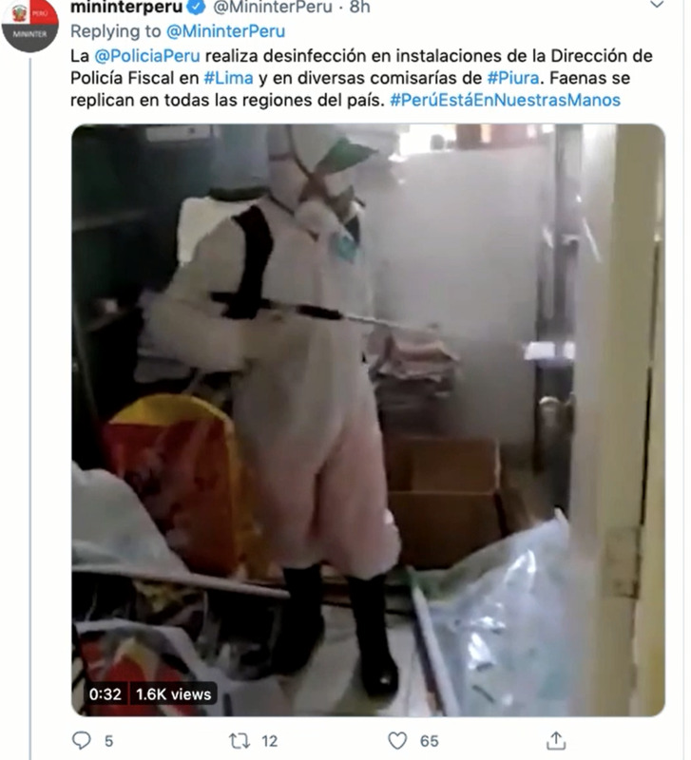
@PoliciaPeru carries out disinfection in facilities of the Fiscal Police Directorate in #Lima and in various police stations in #Piura. Tasks are replicated in all regions of the country. #PerúIsInOurHands

