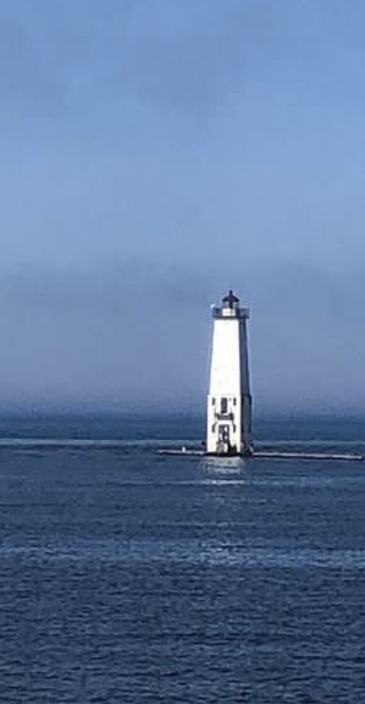
The lighthouse at Frankfort, Michigan
When Covid travel restrictions lifted in the summer of 2020, I hopped in my car for a road trip! I decided to go to a place that I used to live, where I knew I could be outside and be near water and the beach. I stayed in a quaint cabin in a town called Elberta, which is a small rural town along Lake Michigan. On my journey I had to plan my stop for food and gas. I started in Oak Park, Illinois, where gas stations and rest stops were not in full service, and travel restrictions were still in place. I knew that my tank of gas would get me to Michigan where I knew I could fill up and get service if needed. Off I went!
When I arrived, it was as if I landed on a different planet. I was used to strict Covid restrictions and wearing a mask so when I arrived at my destination, it was as if a pandemic had not happened. People were eating indoors, not wearing masks and sitting next to each other. I was not used to this new “freedom,” and I remember feeling uneasy about not wearing my mask in public. I met a friend who I used to work with when I lived in the area, and she mentioned that most people during Covid did not take the lockdown seriously, and because the area was more rural the sense of medical urgency was not present. When my retreat ended, I went home to my urban environment, and I returned to restrictions with masks and social distancing recommended in public places, but the sand in my toes was a pleasant reminder of my travels.

