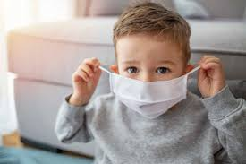
( I didn’t use a picture of my own kids for safety reasons.)

I’m currently a Preschool teacher which means I’m working with 3-5 years old in class. Since Pre-school is still considered a day care type situation I'm still able to be with them in person. One of the tough parts of the job is the kids who are 3-4 years old don't have to wear masks but once the child turns 5 even though they're still in pre-school they have to start wearing masks the whole day. The idea is hard especially since two new five years olds are seeing their other friends not wearing masks and they don’t understand why they have to start wearing them the whole day. It’s a constant reminder for them to pull the masks up. Also the fact that me as a teacher wears the mask and it's hard to express my emotions to the fullest especially since kids this age react strongly to facial expressions. Especially when learning their letter sounds and acting them out. The term using my teacher's voice is now sorted through new heights since I need to speak louder with my mask. Even though I know this is difficult, I do believe we need to use the maska for the greater good. My thought is what makes 5 years different from a 4 year old. Or could wearing a mask be associated with what grade you are instead.

Image from: Mom.com

